

# 

NTU Student Commerce Mobile Application

Ahmad Syfaiq Bin Ahmad Ghozali

Fu Guanqiao

Liu Fenghao

Parthan Muralidharan

Lim Jiayi Joey

Yeo Jia Ying

JustDoIt

School of Computer Science and Engineering, Nanyang Technological University

Submitted to—

Dr Shen Zhiqi

School of Computer Science and Engineering, Nanyang Technological University

Executive Summary **3**

**Statement of Problem** **4**

**Objectives** **4**

**Technical Approach** **4**

Customer Needs 5

Target Specifications 5

Technology Consideration 6

System Architecture/Platform 7

**Project Management** **8**

Deliverables 9

Budget 10

Communication and Coordination with Sponsor 10

Team Qualifications 11

**Appendix A: Résumés of Team Members** **12**

Appendix A1 12

Appendix A2 14

**EDUCATION** **14**

**EXPERIENCE** **14**

**PROJECTS** **14**

Carpark App: App development using Flutter & Firebase Source Code 14

Course Project: Intro to Data Science & Artificial Intelligence 14

**SKILLS** **14**

Appendix A3 15

Appendix A4 17

Appendix A5 18

# Executive Summary

JustDoIt proposes a centralized platform where NTU students can sell or trade their preloved items. Currently, students may put up their items for sale on applications such as Telegram and Carousell. However, with messaging apps, it is difficult for potential buyers to navigate and search for the best deals without an organized catalog. While Carousell may be a viable alternative, it is not exclusive to NTU.

JustDoIt’s mobile application aims to make the buying and selling experience more convenient for NTU students in the following ways:

* Enable filters to narrow down searches
* Keep transactions within campus and in-person to reduce travel time and avoid conflicts that may arise from online payment
* Allow users to trade their second-hand items with one another instead of having just one option of buying

The application will be developed using Android Studio, which contains all the essential tools needed to build apps on Android.

Our project implementation is estimated to be carried out over a period of 10 weeks. Each team member will take charge of their own areas of specialization. Weekly meetings will be held for members to communicate their ideas and keep track of the team's progress.

This proposal outlines how the team will design and implement the system, and what can be expected at certain stages of the project.

# Statement of Problem

Living in a consumerist and first world country like Singapore allows Singaporeans higher purchasing power. Majority of Singaporeans, especially young adults, are shopaholics - meaning they are addicted to purchasing items ranging from clothes to small gadgets despite not having an immediate need for them, which can lead to hoarding and a lack of space to store such items. While there are existing applications allowing for Singaporeans to sell away their second-hand or unwanted items, there has yet to be an application specifically targeted towards NTU students.

As NTU students ourselves, we have identified the need in developing an application for NTU students to sell or trade their second-hand items. As the application is specifically targeted towards NTU students, the need to coordinate a meetup location is reduced greatly. Sellers will also have less competition when compared to a nation-wide application such as Carousell. Users can trade or sell NTU-specific items such as school tees or textbooks.

# 

# Objectives

We seek to fulfill the following objectives during the design of it.

1. First design objective: Security
   1. The system must store users’ account and password safety.
   2. The system must verify user information before allowing access.
2. Second design objective: Flexibility
   1. The system must allow users to add and edit items on their own available list, then the system must make changes on the database.
   2. The system must contain separate modules so that changes on source code must not affect other parts.
3. Third design objective: Correctness
   1. The system must achieve all requirements specified.
4. Fourth design objective: Efficiency
   1. The system must respond to user actions in no more than 10 seconds.

# 

# Technical Approach

To ensure our application is user-friendly, a step-by-step guideline is provided to ensure smooth and easy usage of the registration, login and other functionalities.

Following this section, we will be stating the customer needs, target specifications, technology consideration and system architecture of our application.

## Customer Needs

We have identified the following customer needs to be met in our application:

* Ability to search for a specific item and its details
* Ability to see the rating of a seller to determine their reliability
* Ability to chat with the seller of a specific item
* Ability to list, edit or delete items for sale or trade
* Ability to mark an item the buyer is interested in as Favorite

There are several benefits to using the new application. Currently, there is no existing mobile application for NTU students to sell or trade their second-hand items. Such services only exist in Telegram groups. However, users are unable to search for a specific type or item they want, or determine the seller’s reliability due to lack of information provided.

## 

## Target Specifications

The application may provide the following functions and features:

1. Display a list of items up for sale on the home page
   1. Item names, picture, prices and condition will be shown as cards
   2. Clicking on any item card will bring up more details such as the seller’s information, preferred meet-up point on campus and a chat button
2. Chat between buyer and seller
   1. Clicking on the Chat icon in the detailed item page opens a messaging interface
   2. Buyers can ask for more information such as clearer photos of the product and exact measurements
   3. If the item is available for trading and the buyer wishes to trade, the buyer will be prompted to select an item from their listing before being brought to the chat. A message with the item selected will be sent to the seller for seller to decide whether to accept the item for trading
   4. If the buyer chooses to purchase instead, a chat message with the amount of money offered by the buyer will be sent to the seller
3. Search for specific items and apply filters
   1. Users can narrow down the list of items displayed by typing what they are looking for into the search bar
   2. Items can also be filtered by product condition, price range and seller ratings
4. Rate sellers
   1. Buyers who have made transactions with a seller will be prompted to rate the seller after they have paid and collected their item
   2. Rating refers to giving the buyer a score from 1 to 5 and leaving comments about their overall experience
5. Account creation and management
   1. Students can register for an account by providing their email and contact number
   2. All registered users can sell and/or buy items
   3. Users can change their account password and details in the dashboard
6. Add, edit and remove listings
   1. Under “Manage Listings” in the account dashboard, sellers will be able to view all the items they have put up for sale, organised into the following categories: Active, Sold, Reserved and Removed
   2. Clicking on the ‘+’ button at the top of the page creates a new listing
   3. Clicking on the ‘Remove’ button beside an item takes down the listing from the app’s main page and moves it from ‘Active’ to ‘Removed’
   4. Whenever an item has been collected and paid for, the seller can mark it as ‘Sold’
   5. ‘Reserved’ shows items that have an interested buyer but the buyer has not collected and paid yet
7. Add to Favorites
   1. If a user is interested in item but is not set on buying it yet, they can mark it as ‘Favorite’ and come back to it after looking at other items
   2. Favorited items can be found in the Favorites page

## 

## Technology Consideration

Our application will be designed for Android devices. It will be developed with Android Studio for frontend and Google Firebase for backend. The table below gives a brief introduction to the technologies to be used in the development of the application.

**Table 1:** Brief Introduction of Technologies Used

| **Technologies used** |
| --- |
| **Android Studio** is an integrated development environment specific to Android development. |
| **Google’s Firebase Realtime Database** is used for inserting, updating and retrieval of data. With the help of Firebase, the application is able to receive immediate changes. |
| **GitHub** is a code hosting platform used for collaboration between the team members. |
| **Java** is a programming language used in Android Studio for the development of our application. |
| **MySQL** is a programming language used to query from the database. |

## 

## System Architecture/Platform

The system develops on the Android Platform using MYSQL to develop back-end databases and JAVA to develop front-end user interfaces.

Google Firebase, will be used as our main source of information retrieval and storage, such as storing user details and their listings

The reasons for using Android Studio for our application are due to the following reasons:

* Free to use
* Relatively low software requirements compared to other software development tools
* Customizability and ability to integrate easily with source version control repositories
* Team’s familiarity with the development tool and language

Our team has also decided to use GitHub as our main source version control repository due to our familiarity with interfacing and interacting with the repository, as compared to other SVNs.

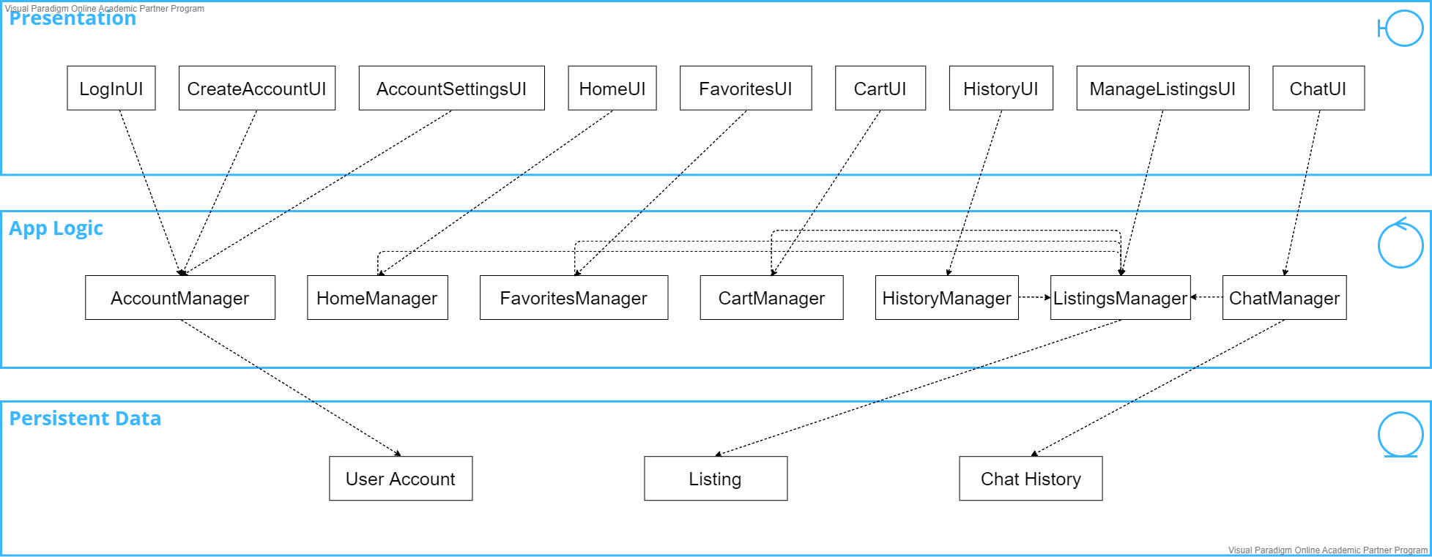

**Figure 1:** System Architecture Diagram

# Project Management

To ensure that the application is completed by the stipulated time, the project manager has come up with a Gantt Chart to facilitate project management.

The team will be following the waterfall model with elements of the Scrum framework in the development phase. Taking into consideration the lab timings and the deliverables for the lab, the project will be carried out in 6 phases with some overlapping portions. Each phase will last roughly 2 weeks. Within the development phase, there will be at least 3 sprint cycles, each spanning 1 to 2 weeks.

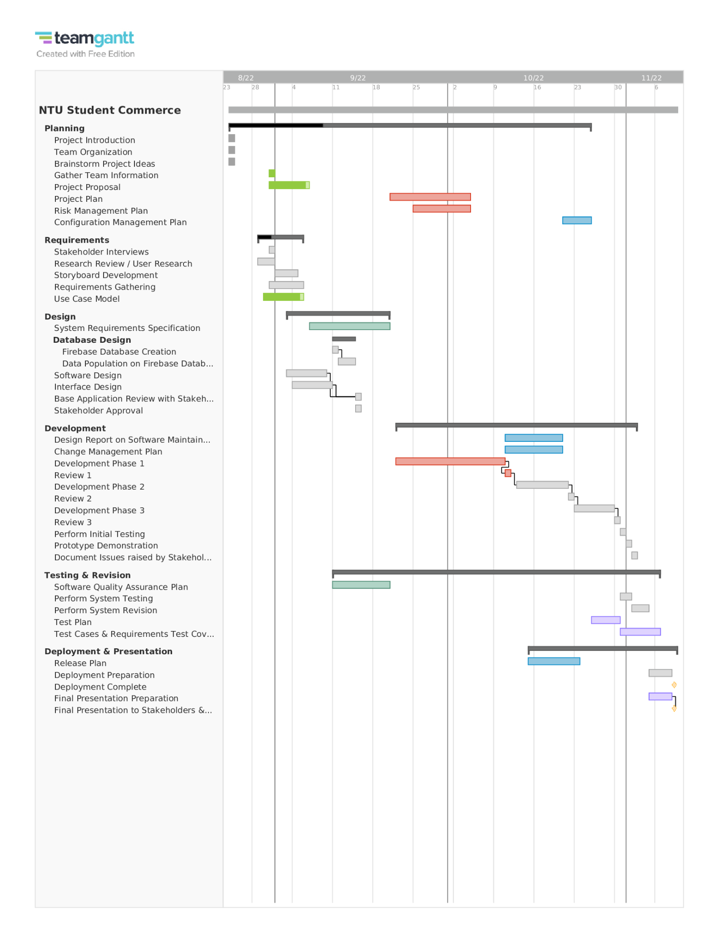

**Figure 2:** Gantt chart for the project

## 

## Deliverables

Therefore, certain deliverables are required at the end of each phase to clearly showcase the details of each phase and the actions taken to complete the application. The following table lists the deliverables due for each phase.

**Table 2:** Deliverables Due at the End of each Phase

| **Phase** | **Duration of Phase** | **Deliverables** |
| --- | --- | --- |
| 1 | 24 August 2022 -  7 September 2022  (2 weeks) | * Team Information * Project Proposal * Use Case Model & Descriptions * Backlog * Weekly Meeting Minutes |
| 2 | 7 September 2022 -  21 September 2022  (2 weeks) | * System Requirements Specifications * Quality Plan * Backlog * Weekly Meeting Minutes |
| 3 | 21 September 2022 -  5 October 2022  (2 weeks) | * Project Plan * Risk Management Plan * Backlog * Weekly Meeting Minutes * Demo: Prototype Demonstration to stakeholders * SVN: Prototype related items (code, documentation, slides, video clips, etc.) |
| 4 | 5 October 2022 -  19 October 2022  (2 weeks) | * Design Report on Software Maintainability * Configuration Management Plan * Change Management Plan * Release Plan * Backlog * Weekly Meeting Minutes * Lab 5 Deliverables to prepare for Live Presentation: * Presentation Slides * Test Plan * Test Cases & Requirements Test Coverage Report |
| 5 | 19 October 2022 -  2 November 2022  (2 weeks) | * Live Presentation * Backlog * Weekly Meeting Minutes * SVN: Project Documentation * NTULearn: Peer Review |

All deliverables are uploaded to MediaWiki unless otherwise stated.

## 

## Budget

The team consists of a project manager and 5 team members. The team excluding the project manager who is in charge of the overall project, is split into two teams one of the into the software development of the project while the other is in charge of the quality assurance. Each team member would work using a personal computer using either MAC OS or a Windows Based Operating system. To cut the cost of living expenses the entire team would be working from home with only meeting physically at NTU for weekly meetings to verify the progress of the project. Furthermore, transportation costs for traveling to school are included in the budget specification.

**Table 3:** Requested items and funds for initial design

| **Item** | **Supplier** | **Quantity** | **Unit Price** | **Total** |
| --- | --- | --- | --- | --- |
| Project Manager |  | 1 | $10,000.00 | $10,000.00 |
| Project Team Member |  | 5 | $5,000.00 | $25,000.00 |
| Computers | Apple/Microsoft | 6 | $1,000.00 | $6,000.00 |
| Database | Firebase | 1 | Free | Free |
| Office Rental | NTU | 1 | $1,000.00 | $1,000.00 |
| Transportation | MRT | 1 | $100.00 | $100.00 |
|  |  |  | **Total** | **$42,100.00** |

## 

## Communication and Coordination with Sponsor

As this project is conducted under supervision of the CZ3002 Advanced Software Engineering course part of the NTU Computer Science curriculum, the development of this application is sponsored directly by the SCSE Faculty. Therefore, during the Lab Sessions the project team will be coordinating with the sponsors to ensure that we are consistently meeting the stakeholder/sponsor requirements. Furthermore the project manager will present the team’s progress to the sponsors so that the team can find areas to improvement and make sure that the final products meets their expectation.

## 

## Team Qualifications

The JustDoIt project team is duly qualified to take on this project, as each of the team members has – respectively – backgrounds that would enable them to take on the roles and responsibilities assigned. Each member’s resume is therefore attached in Appendix A of this proposal to support everyone's qualifications. The table below gives a brief introduction of each member and their qualifications.

**Table 4:** Members Qualifications

| **Member Name** | **Qualifications** |
| --- | --- |
| Ahmad Syafiq Bin Ahmad Ghozali  (refer to Appendix A1 for resume) | Ahmad Syafiq is currently an undergraduate student from Nanyang Technological University. His internship experience of leading teams that are based overseas working on projects that have already been developed has allowed him to meet the requirements of this project as well as been give the role of project manager |
| Lim Jiayi Joey  (refer to Appendix A2 for resume) | Lim Jiayi Joey is a 3rd year undergraduate studying at Nanyang Technological University. Her previous internship experience of backend programming has allowed her to meet the requirements of this project. |
| Fu Guanqiao  (refer to Appendix A3 for resume) | Fu Guanqiao is a year 3 student currently studying at Nanyang Technological University. His previous project experience of developing and testing meets the requirements of this project. |
| Liu Fenghao  (refer to Appendix A4 for resume) | Liu Fenghao is currently a Y3 student from Nanyang Technological University. His knowledge on programming and project experience have allowed him to meet the requirements of this project. |
| Yeo Jia Ying  (refer to Appendix A5 for resume) | Yeo Jia Ying is currently a Year 3 undergraduate student at Nanyang Technological University. Her experience in course projects has allowed her to meet the requirements of this project. |

# Appendix A: Résumés of Team Members

## Appendix A1

**AHMAD SYAFIQ BIN AHMAD GHOZALI**

**QA TESTER**

LinkedIn: linkedin.com/in/ahmad1syafiq | Mobile No.: (+65) 9069 4916 | Email: asyafiq.ag@gmail.com

EDUCATION

**Bachelor of Engineering (Computer Science)** Aug 2020 – Present

*NANYANG TECHNOLOGICAL UNIVERSITY, SINGAPORE*

ACADEMIC PROJECT

**Nanyang Technological University, Singapore** Jan 2022 – Feb 2022

**Virtual Reality Project – To ‘Gamify’ environmental concept to make concepts fun as well as engaging**

• Developed and fully tested VR Game to meet standards of professor

• Optimized load times by including load transitions to help process game assets.

INTERNSHIP EXPERIENCE

**MatchMove Pay Pte. Ltd.** Mar 2017 – Aug 2017

***User Experience & QA tester, Intern***

• Worked and tested company’s flagship financial application that is deployed internationally

• Worked with other QA testing teams in the South-east Asia region

• Assisted with the testing and deployment of multiple Major Updates throughout my tenure at the company

WORK EXPERIENCE

**Ngee Ann Polytechnic** Mar 2017 – Jul 2018

**Temporary IT Staff**

• Helped to test and check Lab computers are ready for the next semester

• Responsible to fix issues that lectures face daily

SKILLS

Digital Skills: C#, C++

Software: Blender, Microsoft Office, Windows and Unix OS

## Appendix A2

JOEY LIM

[jlim356@e.ntu.edu.sg](mailto:jlim356@e.ntu.edu.sg) · +65 91825971

[LinkedIn](https://www.linkedin.com/feed/) · [Github](https://github.com)

A long, thin rectangle to divide sections of the document

# EDUCATION

Aug 2020 - May 2024 NTU *— BACHELOR OF ENGINEERING IN COMPUTER SCIENCE*

Jan 2014 - Oct 2019 River Valley High School *— A-LEVELS*

# EXPERIENCE

May 2022 - Jul 2022 UDream Entertainment *— Game Programming Intern*

Experimented with many different languages such as PHP, and Lua on softwares such as Unity and Rider. Also touched on database management using MySQL and Javascript and HTML for display.

# PROJECTS

## Carpark App: App development using Flutter & Firebase [Source Code](https://github.com/devanshk22/car_park_app)

With Google Firebase as backend service, developed an application with Flutter to display the nearby car parks and relevant information according to the user’s current location on a map.

## Course Project: Intro to Data Science & Artificial Intelligence

Conducted exploratory analysis on an e-commerce public dataset by Olist to measure factors of success. Used techniques such as multivariate linear regression, test-train splits and sentiment analysis.

# SKILLS

**Programming Languages Others**

Java | Python Flutter Development in Dart

Prolog | MySQL Machine Learning (Numpy, Pandas, Scikit- Learn)

## Appendix A3

**FU GUANQIAO | Mobile No.: 85910344 | Email: guanqiaofu@gmail.com**

**EDUCATION**

**Nanyang Technological University, Singapore** Aug 2020 – Aug 2022

**Bachelor of Engineering (Computer Science)**

**Nanyang Technological University, Singapore** June 2019 – June 2020

**Bridging Course**

**ACADEMIC PROJECT**

**Nanyang Technological University, Singapore** Feb 2022 – May 2022

**Software Engineering Project – Design a web app for tracking daily food purchase and consumption**

• Developed a tool for people to record food storage and nutrient information.

• Calculated the food intake and provided the calorie information of various food categories.

**Console-based Project – Design an ordering system of restaurant for the staffs**

• Enabled staff to place an order or reservation on this system.

• Deploy database to enable staff to make changes to various information.

**Artificial Intelligence Project – Design a mini game with agent and Wumpus World**

• Create the Wumpus World with different elements in it such as wall or trap.

• Implement an agent which can detect various dangers in the Wumpus World.

**Data Science Course Project – Relation between Stock price and Company finance**

• Found correlation between estimated earning and volume for some companies.

• Conclude little correlation between the fluctuation of price and volume.

**WORK EXPERIENCE**

**Reception Assistant of Retail Banking** Dec 2019 – Jan 2020

**Bank of China** China

• Worked as the first line of customer service, attended to customers’ requests (account

opening, mobile banking set-up etc.), which improved efficiency for banking business.

**SKILLS**

Languages: English (Fluent) and Mandarin (Native)

Digital Skills: C, Python, Java, MySQL, Prolog

## Appendix A4

**LIU FENGHAO | mobile number: 86982538 | Email: liufenghao52@gmail.com**

**EDUCATION**

**Nanyang Technological University, Singapore** August 2019---May 2024

**Bachelor of Engineering (Computer Science)**

• SM2 scholarships for entire education with a Bridging Year before Year one.

• NANYANG TECHNOLOGICAL UNIVERSITY, SINGAPORE.

**ACADEMIC PROJECT**

**Nanyang Technology University, Singapore**  March 2021---May 2021

• Year one Mini-Project: Analysis the data of the amount of stock and corresponding revenue.

• Deployed Jupyter Notebook and Python to plot company’s revenue and stock data sets.

• Analysis relations between stocks and company revenue, using API to get monthly data.

**Year two Project: Object Oriented Design & Programming Java.**

• Developed a complete restaurant ordering system with Java and database, then draw corresponding diagrams.

• Acquired knowledge of application logic structure.

**Year two Project: Website application development.**

• Delivered Java to construct structure of application, take Django and Heroku to devise One-Tracker application in website.

• As leader of team, learnt how to lead a team.

**Year two Project: Agent and Wumpus Game.**

• Operated knowledge base, Python and Prolog to create a Wumpus World and a moving agent in it.

**CO-CURRICULAR ACTIVITIES**

**Performance of cross talk**  August 2021—November 2021

• Wrote own script of cross talk and performed on NTU crosstalk party.

**SKILLS**

• Languages: Chinese and English and a little bit Deutch.

• Computational skills: python, C, Java.

• Digital skills: Microsoft Office, Geometer sketchpad and Visual Paradigm.

**HOBBIES AND INTERESTS**

• Sports: football, badminton;

• Art: play violin and guitar;

• Other: travelling.

## Appendix A5

**Yeo Jia Ying | Mobile No.: 8396 8033 | Email:** [**C200190@e.ntu.edu.sg**](mailto:C200190@e.ntu.edu.sg)

**EDUCATION**

**Nanyang Technological University, Singapore** Aug 2020 – Present

**Bachelor of Engineering (Computer Science)**

**ACADEMIC PROJECTS**

**Nanyang Technological University, Singapore** Jan 2022 – Apr 2022

**Software Engineering Team Project – Develop a web application for comparing school information deployed in Firebase**

* Implemented functionalities in Favourites and Dashboard pages using ReactJS and Firebase JS SDK tools
* Documented results of manual boundary value testing and basis path testing for main functions, ensuring results met all functional requirements set
* Learned basic Javascript, HTML, CSS and ReactJS in the process

**Nanyang Technological University, Singapore** Sep 2021 – Nov 2021

**Object-Oriented Design & Programming Team Project – Build a console-based OO application**

* Implemented controller functions required for the restaurant reservation and POS system in Java, making use of interfaces to reduce dependencies
* Came up with test cases and did manual testing and debugging to ensure application was able to fit requirements

**Nanyang Technological University, Singapore** Mar 2021 – Apr 2021

**Introduction to Data Science & AI Team Project – Predict Oscar Best Picture nominees using Machine Learning models**

* Applied Decision Tree model to gain a rough estimate first. Improved classification accuracy by removing variables deemed less important in Logistic Regression and Feature Importance analyses
* Obtained a list of 21 predicted nominees, including all 7 actual nominees
* Learnt how to use Pandas and Seaborn libraries for data visualisation

**SKILLS**

Programming Languages: Python, C, Java, ReactJS, PHP

Certifications: Building Web Applications in PHP (Coursera) – 2022

Other Digital Skills: Rhino3D, Inkscape